1.Find the e_no and ename of the employee whose salaryis greater than 4000

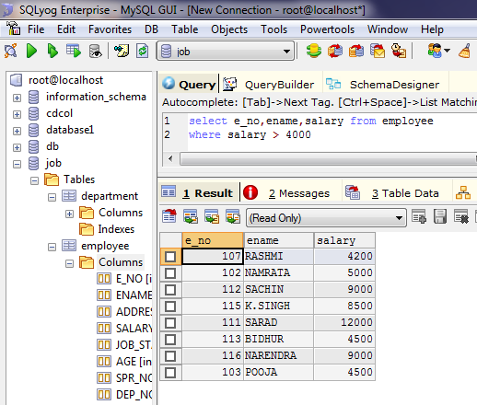

COMBINING CONDITIONS AND BOOLEAN OPERATION

2.Find the e_no , ename , salary of the employee whose salary is greater than 5000 job status is professor.

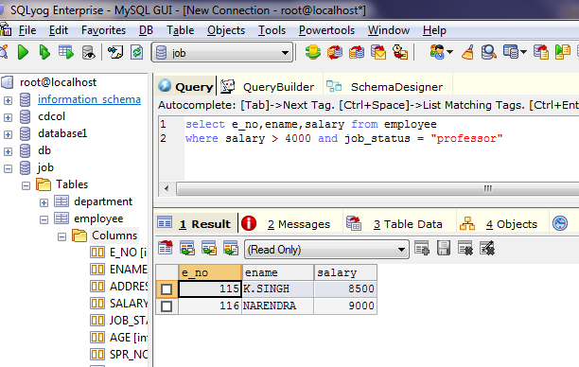

ADDRESS OF ALL THE EMPLOYEES.

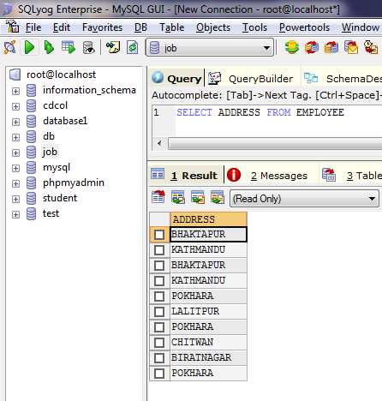

REMOVING DUPLICATES

DISTINCT ADDRESS OF EMPLOYEES.

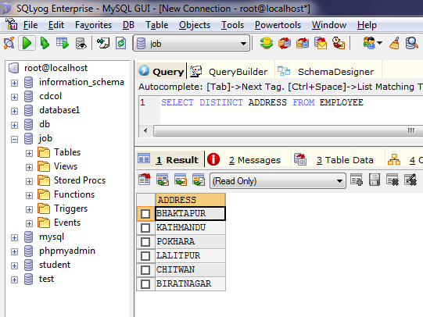

FIND THE ENO,ENAME,SALARY OF THE EMPLOYEE WHOSE DEPARTMENT NUMBER 20 OR JOB STATUS RESEARCH FELLOW.

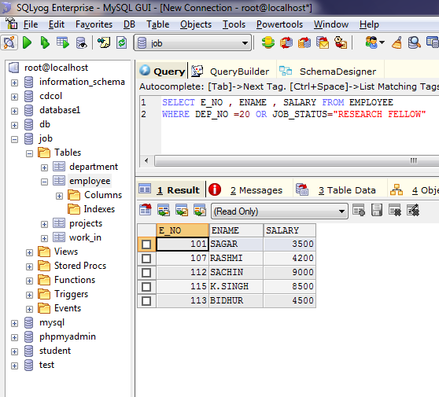

RANGE SPECIFICATION

FIND THE ENO,ENAME AGE AND SALARY FROM THE EMPLOYEE WHERE THE AGE IS BETWEEN 24 AND 28

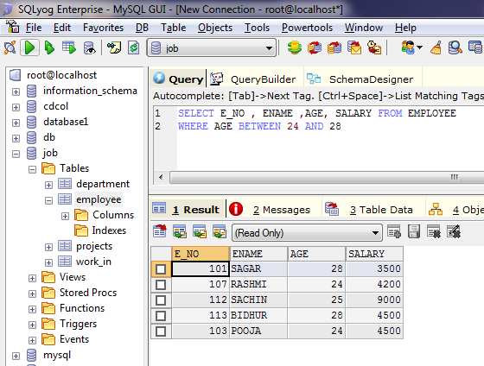

‘ABC%’ ALL STRINGS STARTING FROM ABC.

‘%XYZ’ ALL STRING THA ENDS WITH XYZ EG : ZZXYZ

‘%A N %’ ALL STRINGS THA CONTAINS THE PATTERN ‘AN’ ANYWHERE EG: PRANESH ,PANKAJ ETC

FIND E_NO,ENAME WHOSE STARTING LETTER IS “SA”

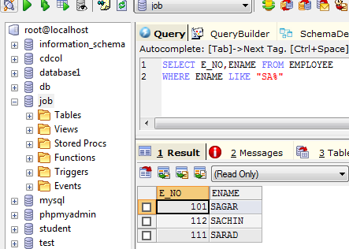

1.LIST ALL EMPLOYEE NAMES WITH THEIR PROJECT NAMES.

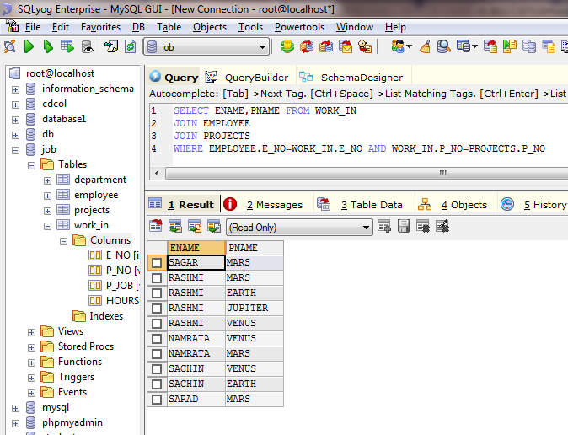

2. LIST NAME OF ALL EMPLOYEES AND THEIR SALARY WHO ARE WORKING IN PROJECT MARS OR VENUS.

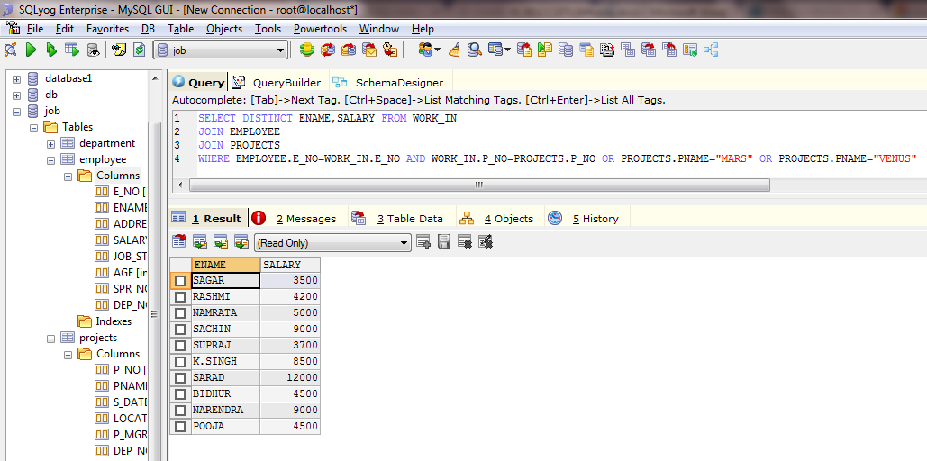

3. LIST NAME OF ALL EMPLOYEE AND THEIR SALARY WHO ARE WORKING ON PROJECT EARTH AND VENUS.

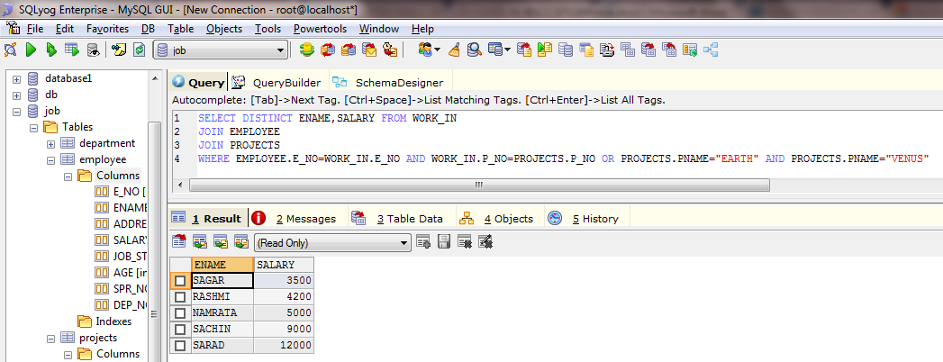

4. LIST NAME AND ADDRESS OF ALL EMPLOYEE WHO WORKS IN DEPARTMENT WHICH IS LOCATED IN POKHARA.

